- \Operation\Infeed conveyor\Infeed conveyor 2
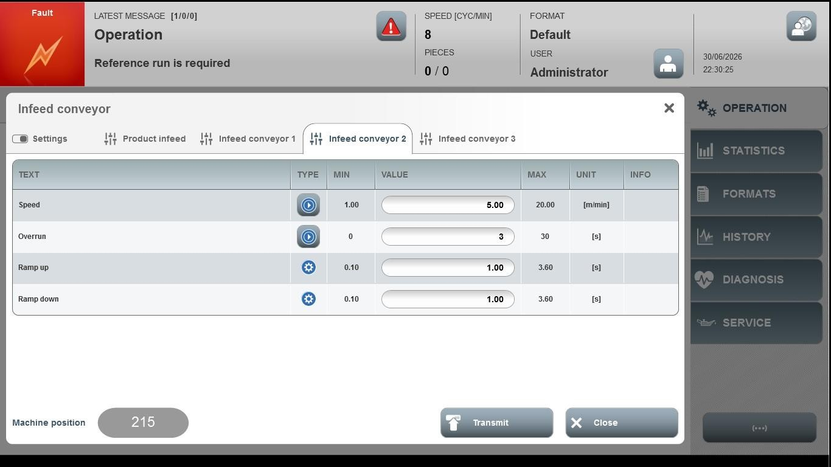
Acceptance criterion | Limits | Pass / Fail: Dev-No. | Date | Initials
Screen matches screenshot | N / A
Speed | 1.00 … 20.00
Overrun | 0 … 30
Ramp up | 0.10 … 3.60
Ramp down | 0.10 … 3.60

